**Ticket Life Cycle in Jira**

Ticket life cycle refers to the stages that an issue goes through from start to finish

**The ticket life cycle stages in Jira:**

1. To do: The ticket is created is waiting to be worked on
2. In progress: someone has started working on the ticket and they doing the task
3. Resolved: The work on the is finished and its ready to review to make sure that everything is perfect
4. Done: The ticket is done .it means the task is completed

**Test the ticket life cycle in Jira:**

1. First we create a bug in Jira select the issue type and enter the details like

Issue type: Bug

Summary: login button not working

Description: users are unable to log in when clicking the login button

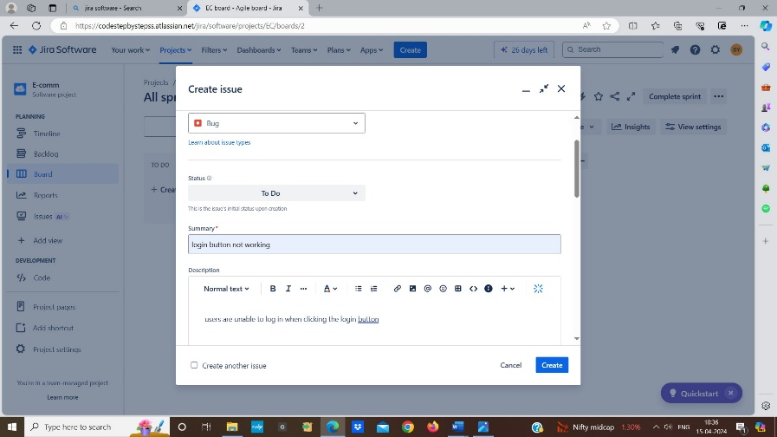

1. Then assign the ticket to developer who will fix the bug

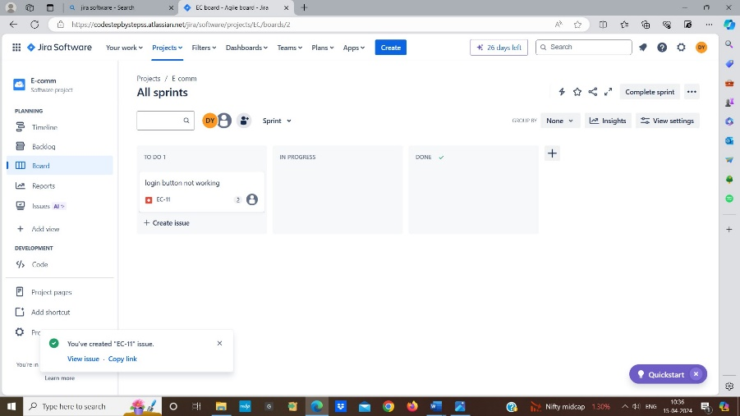

1. Developers changes the status of the ticket to “In Progress” to indicate that they are working on the bug

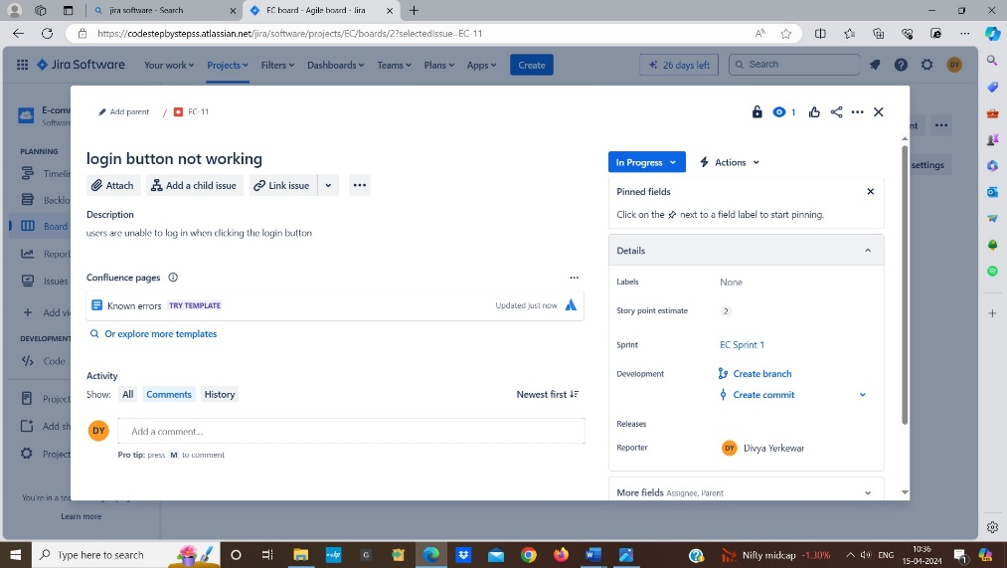

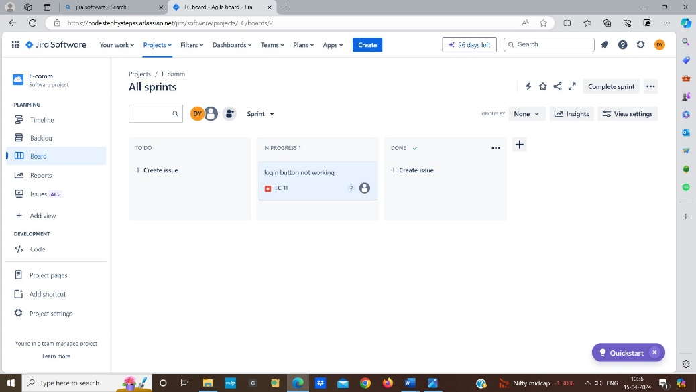

1. Developer fixes the issue and changed the status of the ticket to “Resolved”

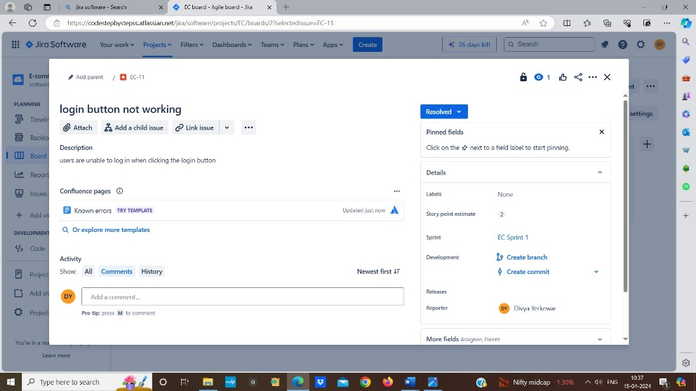

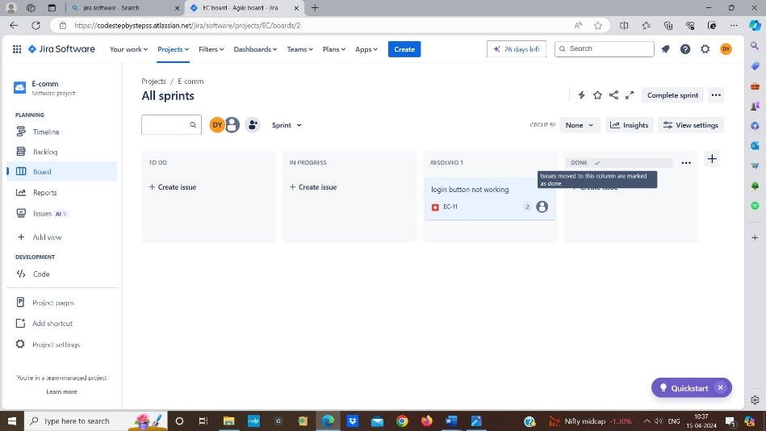

1. Tester receives the ticket and tests the fix issue if the login button now works the tester closes the ticket and changes the status of the ticket is “Done”

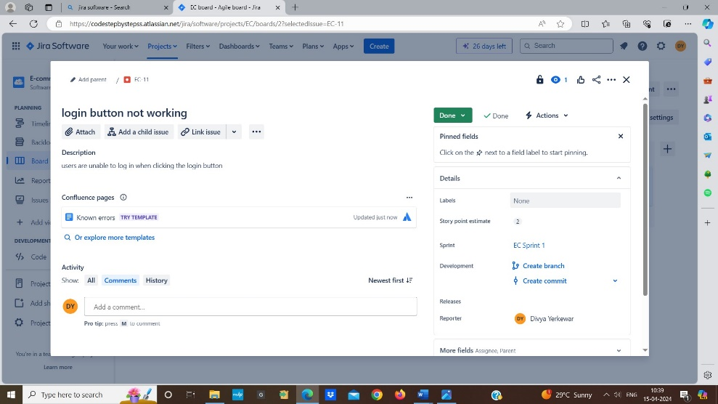

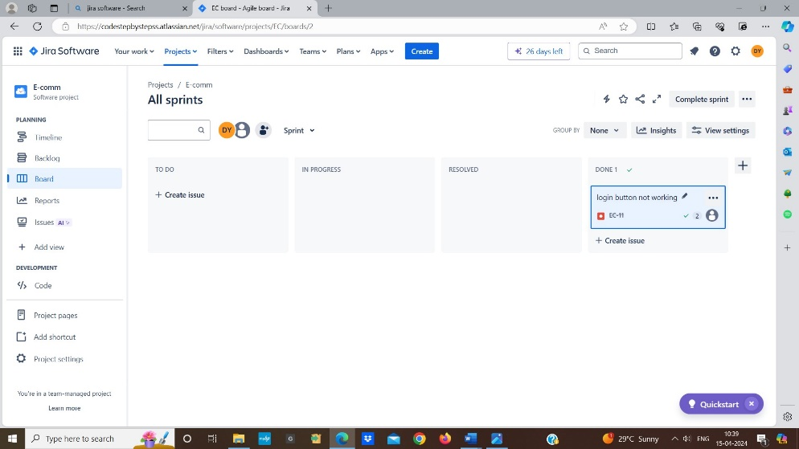

1. If the issue is not resolved the tester reopens the ticket